**DUMB CHARADES**

**INCEPTUM 2K14**

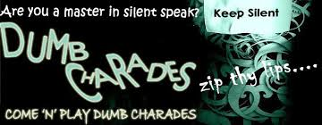

**RULES AND INSTUCTION:**

* There will be a team of two members.
* Both the participants should be at the event place on the given time otherwise their registration will be cancelled.
* There will be two rounds in this event and in each round a movie will be given to each team.
* In FIRST ROUND one of the team members will be dumb and other will have to guess the movie performed by his/her partner in given time.
* Teams who will guess the correct movie in the given time will be qualified for the next round.
* In SECOND ROUND each team will perform two movies. Both the member will have to act alternatively.
* The total time in guessing both movies will be added and the team who will guess the movies in minimum time will be announced as the winner team.

**COORDINATORS-**

AKANKSHA GAUTAM (ECE 2nd year)

DIKSHA SINGH (ECE 2nd year)

ASHISH BALIYAN (ECE 2nd year)